PHY 108
Assignment 2

You do not need to include the question paper with your answer script.

1) In figure 1, R is a circular ring of charge having line charge density λ and radius 3cm. Find, in terms of λ, the net electric field at point P which is 15cm away along the axis of the ring.
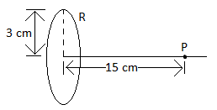

Figure 1

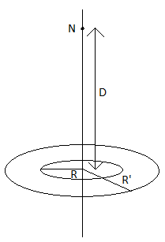
2)
Figure 2 shows two concentric rings of radii R and R’ = 3R that lie on the same plane. Point N lies on the central z-axis, at distance D = 2R from the center of the rings. The smaller ring has uniformly distributed charge +Q. In terms of Q, what is the uniformly distributed charge on the larger ring if the net electric field at N is zero?

Figure 2

